Westbury Arts Centre

Annual Report 2018
&
Financial Statements

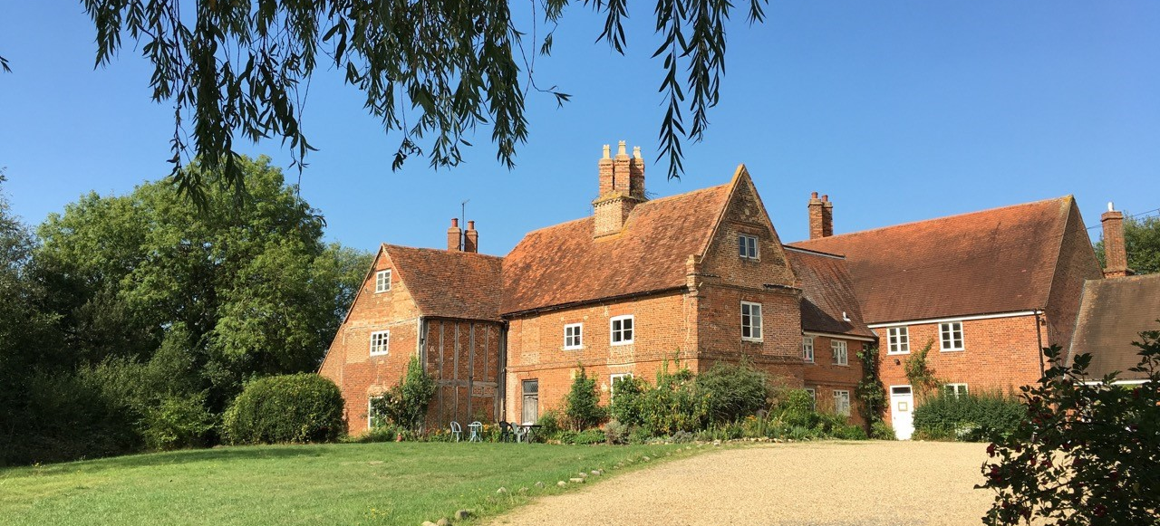

WESTBURY ARTS CENTRE
(Limited by Guarantee)

CONTENTS | PAGE
Report of the Trustees | 3 - 6
Legal and Administrative Information | 7 - 10
Financial Statements | 11
Trustees’ Responsibilities to the Financial Statements | 12
Independent Examiners Report | 13
Statement of Financial Activities | 14
Balance Sheet | 15
Notes to the Financial Statements | 16 – 21

Mission and Objectives

Westbury Arts Centre is a studio providing venue. Situated on the western flank of Milton Keynes. The Charity’s mission agreed in the Business Plan (2016-2021):

‘To be a creative community that engages people of all ages and abilities in active discovery and exploration of the arts, heritage and the local environment.’

The key objectives are:

- Artistic development through provision of affordable studios. Opportunities for professional development to a range of artists and makers through encouraging and supporting a strong artistic community.

- Community and co-production, offering a rolling programme of affordable events, workshops and activities across a range of disciplines for people of all ages and abilities. Engage other organisations and groups in artist-led co-production.
In order to achieve these, the objectives also cover: ensuring that the facilities are fit for purpose and fully utilised: ensuring strong governance and development of the organisational structure.

Westbury is delivering to the emerging Creative and Cultural Strategy and its vision for the city – ‘Milton Keynes, where creative experiences and opportunities transform lives’. Our work contributes to this vision in the areas of Empowered Citizens, Enhanced Cultural and Creative Industries.

Key Achievements in 2018

- Significant increase in workshop programme and doubling the attendance.
- Successful outcome of HLF My Heritage grant – major exhibition shown at multiple venues on history of Westbury Manor, entitled ‘Milton Keynes’s Hidden Jewel’.
- Further projects around heritage including development of a website and archiving of art centre history.
- All studios fully occupied.
- Residency awarded to graduate.
- Professional development – sessions on use of social media in marketing.
- Family and children programme fully implemented – Easter event focused on rhyme. Trial of regular sessions for young artists.
- Partnerships maintained and new partnerships developed – working with City Development Centre on Pilgrim’s Trail project.
- Office move enabling establishment of new workshop/exhibition space – The Legge Gallery.
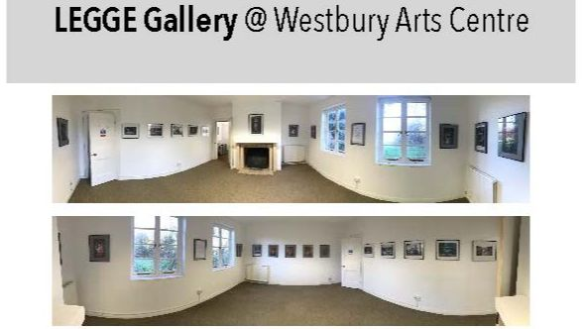

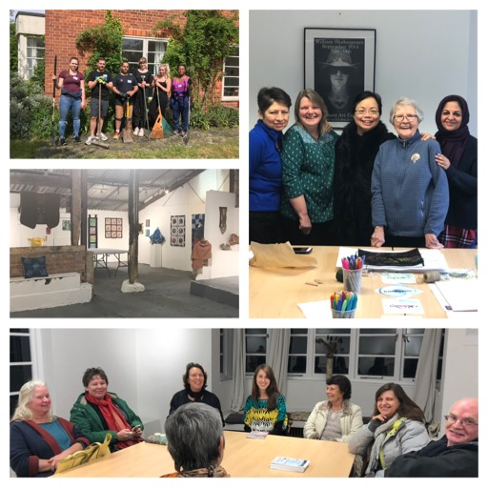
Key Achievements

- Total number of attendees/visitors to Westbury 4669

- Event attendees and other visitors 2400*

- Workshop Attendees 1771**

- Exhibition attendees 498

- Number of workshops (includes band rehearsals, permaculture, corporate volunteer days) 404

- Number of exhibitions held 9

- Volunteers: gardeners, events, corporate volunteers, exhibitions 35

- Funding received from grants £9700

* includes corporate volunteers and other visitors
**includes attendees held by other organisations to give a more accurate measure of how the facilities are utilised

Workshops

Increased opportunities for workshops. Increasing both the number held and a two fold increase in attendees. Achieved with the support of a MKC grant which enabled WAC to increase the paid working hours of the Administrator who was able to develop and market new workshops.

The scope of subjects covered extended to include:

These were marketed at a wide range of abilities and ages including a programme of workshops for children during school holidays. In addition to the publicised workshops and courses, other organisations held professional development and community focused workshops, including Westbury Fabric & Fibre Crafters Guild which meets weekly and offers demonstrations and talks to its members.

Heritage

A group of volunteers worked together to research the history of Westbury Manor. Their contribution was outstanding, producing a booklet and exhibition panels which received widespread praise. The initial exhibition was held at Westbury then to a month at MK Central Library, then displayed again at our HOD’s event in September. Some panels were also put on display at an open day at the County Archive Office in Aylesbury. It has been a most rewarding project and has contributed to the heritage of Milton Keynes. A website is under construction which will ensure that the materials are accessible to the public and to local history researchers.

The group has continued to follow up their research and a further exhibition is planned for 2020 looking at the house in more detail. A family friendly Easter event in 2019 will feature an interactive tour of the house as it was in 1684.

The project also involved many people from other organisations – two school projects – Long Meadow School and Shenley Brook End, The Heritage Society, MK Natural History Society who carried out environmental surveys of the grounds and whose report formed part of the exhibition, Living Archive and resident artists and staff of Westbury.

It has firmly established Westbury Arts Centre as a champion of MK heritage and enhanced the knowledge and materials available for Heritage Open Days and other events. Further projects focusing on Westbury’s history are planned.
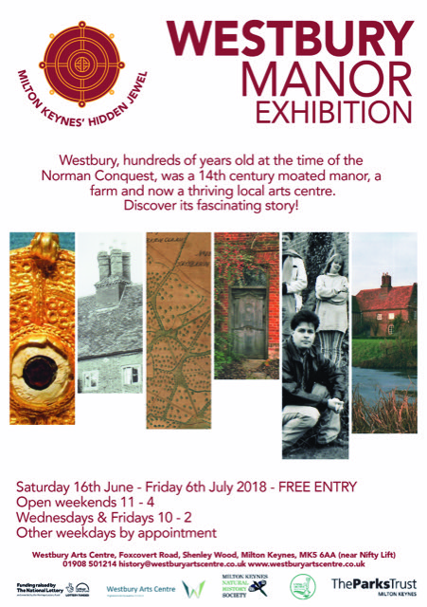

Partnerships and Community Engagement

Westbury continued to engage in activities involving local organisations:

- The “Planting Up’ community garden project was initially formed by a few passionate people from Transition Town Milton Keynes in the summer of 2017 to establish a community garden at Westbury Arts Centre that uses permaculture principles to improve the Arts Centre’s outdoor space to better serve the local community and the natural environment.
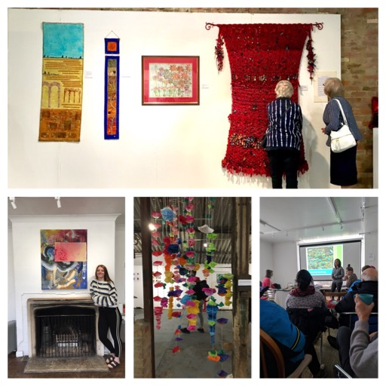
- Westbury Fabric and Fibre Crafters Guild – meet regularly at Westbury and hold an annual exhibition. Membership increased to 115 on their mailing list and 25 full members by the end of 2018.

- MK College – students held two exhibitions at Westbury during 2018.

- Several local bands continue to use Westbury for rehearsals and recording.

- The Community Team for Adults with Learning Disabilities have been holding weekly art therapy sessions for over 12 years.

- The Patchwork People – a local quilting group chose Westbury to hold their annual exhibition.

Westbury continues to participate in:
- Bucks Open Studios
- Heritage Open Days
  - During this event in 2018, we hosted Laura Cooper, Tracing the Pathway, one of the artists from the MK wide Groundworks Project.

Facilities
- A new caretaker moved into Westbury in April. She has made a significant contribution to the community and assisting the Administrator with some of the maintenance management as well as working with volunteer groups.

- The office was moved to a smaller space, which has enabled the old office to become a new workshop and exhibition space, The Legge Gallery. This has increased capacity considerably and is offering opportunities for pop-up events to local artists and organisations.

LEGAL AND ADMINISTRATIVE INFORMATION

DIRECTORS/TRUSTEES: Mr M Compton
Mr L Fennell
Mrs C Malone
Mrs K Holuj
Ms L Davis (Resigned 19/2/19)
Mr J Little
Ms C Butler (Joined 29/3/19)

REGISTERED OFFICE: Westbury Farm
Foxcovert Road
Shenley Wood
Milton Keynes
MK5 6AA

CHARITY NO: 1151531

COMPANY NO: 8328547

INDEPENDENT EXAMINERS: Tearle & Carver Limited
Chartered Accountants
Chandos House
School Lane
Buckingham
MK18 1HD

REPORT OF THE TRUSTEES FOR THE PERIOD ENDED 31 DECEMBER 2018

The Trustees present their report along with the financial statements of the charity for the period ended 31 December 2018.

Structure, Governance and Management
The organisation is a charitable company limited by guarantee, incorporated on and registered as a charity (number 1151531) on 12 December 2012. The company began its charitable activities on 1 April 2013.

The charity was created by its Memorandum of Association which established the objects and powers of the charitable company and is governed under its Articles of Association. The full list of Trustees who served during the period is shown on page 3.

The Trustees meet regularly as an executive board and are advised on all material matters as they occur. They take decisions on the various projects the charity undertakes.

Risk Management
The Trustees have examined the major risks and operations that the charity faces during the financial year. They are continually taking action to ensure that the risks are minimised as much as possible.

Objectives
In setting the programme each year, the Trustees have regard to both the Charity Commission’s general guidance on public benefit and meeting the charity’s objectives outlined above for the public benefit. The Trustees always ensure that the programmes undertaken are in line with the charitable objects and aims.

Financial Review
In the period to 31 December 2018, the Company made a surplus of £2,821 which was added to Total Funds. The total amount of reserves carried forward amounts to £25,418.
The Company’s reserves policy is to retain a minimum of £5,000. The Company continually monitors the financial position and expenditure is only incurred from available funds.

Achievements and Performance
We review our aims, objectives and activities each year. This review looks at what we achieved
and the outcomes of our work from January to December 2018 and indicates progress into 2019.

The review also helps us ensure our aim, objectives and activities remained focused on our stated purposes. We have referred to the guidance contained in the Charity Commission’s general guidance on public benefit when reviewing our aim and objectives and in planning our future activities. In particular, the trustees consider how planned activities will contribute to the aims and objectives they have set.

Governing document
The organisation is a charitable company limited by guarantee, incorporated on 12 December 2012 and registered as a charity on 6th April 2013. The company was established under a Memorandum of Association which established the objects and powers of the charitable company and is governed under its Articles of Association. In the event of the company being wound up members are required to contribute an amount not exceeding £10.

Membership of the trust is open to any individual over the age of 18 interested in promoting its objectives and each of whom will have:

- applied to the trust in the form required by the trustees
- been approved by the trustees, whose decision shall be final
- expressed in writing their personal agreement with the mission statement and objectives of the charity.
There are currently 7 members.

Recruitment of new trustees
As set out within the Articles of Association:

- the chair of the trust is nominated by Westbury Arts Centre.
- the trust maintains a register of members.
Unless the trustees or the trust in a general meeting shall make other provisions under Article 61, the trustees may in their absolute discretion permit any member of the trust to retire provided that after such retirement the number of members is not less than 3.
The trustees may establish different classes of membership and prescribe their respective privileges and duties and set the amounts of any subscriptions. The trustees shall permit such organisations as they approve to become Associate Members, with such entitlements as the trustees shall prescribe. For the avoidance of doubt Associate Members shall not have any of the usual entitlement of a member of the company.
The Board of Trustees consists of elected members and can include co-opted members. Elected members are appointed at the Annual General Meeting and the co-opted members are appointed by a meeting of the committee.
The Board has the potential for representation from other organisations in the form of non-voting advisors and regularly updates the Milton Keynes Council Arts and Culture Manager.

Induction and training of new trustees
New trustees receive training and paperwork outlining their legal obligations under charity and company law and the content of the Memorandum and Articles of Association. Two new trustees were appointed during 2018 and confirmed at the AGM in 2018. One trustee stepped down after taking on a paid administrative role for the centre. She continues to attend Board meetings and to chair the Programme Group.

The Board continued to recruit new trustees and appointed one new trustee during 2019. The Board plans to continue seeking to recruit new trustees with expertise in business planning, marketing and fundraising through advertising and networking in the future.

Organisational structure and governance
The Board of Trustees is responsible for overall control and responsibility for policy and major decision making. The Board and sub-groups met as required and all Board meetings were quorate. The Board continue to act as executives as well as trustees although the increased hours of the Administrator and additional support from Julia Canham has been of great assistance.

There are three working groups and also a named representative for the house artists – the working groups are:
- The Programme Group – developing the annual programme of exhibitions, open days, projects etc. and liaising with the studio artists.
- The Maintenance Group – overseeing the maintenance of the house and grounds.
- The Fundraising Group – responsible for preparing funding bids.
In addition, there is a caretaker who lives on the premises.

The existing structure is still insufficient to provide adequate support to the Board and the charity and compares unfavourably with similar charities which receive core funding. We will seek to secure funding for projects and organisational development, recognising that our organisational structure requires substantial strengthening to enable us to develop our charitable offering.

The Business Plan action plan was reviewed but external events have overtaken the relevance of the original Business Plan – initially an offer of negotiating to take over Westbury by MK Community Foundation which was itself put on hold as MK Council Culture and Development team saw Westbury as a potential cultural asset and has been working with the Board and with MK Council to implement this decision. The final decision rests with MK Council Cabinet. A new Business Plan will be needed as a change in ownership would create a new and welcome context for Westbury. MKDP, our current landlords, produced a one year lease which was agreed in December.

Volunteering
Volunteers play a vital role at Westbury as there is a limited amount of paid employee time. There are two main sources of volunteers:

- The studio artists and Board members themselves who carry out an executive function as well as a governance function together with a regular group of friends of Westbury.
- External volunteers from BT, Network Rail, The Green Gym, members of Letnet. Undertook 6 days of work during 2018 which included painting, decorating and clearing the garden.

Major risks, reviews and systems to mitigate risks
Regular discussions and monthly monitoring of the fund balances, income and expenditure have enabled the trustees to identify risks and to take action in the short and medium term. The charity’s policies and practices are reviewed annually including Health and Safety, Safeguarding Vulnerable Adults, Safeguarding Children and Young People, Equal Opportunities, Best Practice for Volunteers code and Policy on Rent Arrears.

MKDP have drawn up a significant programme of structural work and maintenance which should ensure the main building is secure and in a better state of repair but the expected programme has not started and no date has been specified for the programme.

Board cohesion was good with the new programme of bi-monthly Board meetings and sub-groups reporting to the Board worked well and has led to a great improvement in Board cohesion and effectiveness.

Capacity is still a key issue as much of the work is done by trustees and volunteers. Our administrator has continued to support us with excellent skills and enthusiasm.

Procedures are in place to ensure compliance with health and safety of volunteers, contracted service providers, and visitors. All events are risk assessed beforehand.

WESTBURY ARTS CENTRE
(a company limited by guarantee)

FINANCIAL STATEMENTS

FOR THE YEAR ENDED
31 DECEMBER 2018

Trustees’ Responsibilities in relation to the Financial Statements

Company law requires the Trustees to prepare financial statements for each financial year which give a true and fair view of the state of affairs of the charitable company and of the profit or loss of the company for that year. In preparing these financial statements the Trustees are required to:

select suitable accounting policies and then apply them consistently;

make judgements and estimates that are reasonable and prudent;

prepare the financial statements on the going concern basis unless it is inappropriate to presume that the charitable company will continue in business.

The Trustees are responsible for keeping proper accounting records which disclose with reasonable accuracy at any time the financial position of the company and enable them to ensure that the Financial Statements comply with the Companies Act 2006. They have general responsibility for taking such steps as are reasonably open to them to safeguard the assets of the charitable company and to prevent and detect fraud and other irregularities.

This report has been prepared in accordance with the small companies’ regime under the Companies Act 2006.

Approved by the Board on ………………………………..
and signed on its behalf by

........................................................
Trustee – L Fennell

INDEPENDENT EXAMINER’S REPORT TO THE TRUSTEES OF WESTBURY ARTS CENTRE (LIMITED BY GUARANTEE)

I report on the accounts of the company for the year ended 31 December 2018 which are set out on pages 10 to 18.

Respective responsibilities of trustees and examiner

The charity's trustees are responsible for the preparation of the accounts. The charity’s trustees consider that an audit is not required for this year under section 144 of the Charities Act 2011 (the Charities Act) and that an independent examination is needed.
It is my responsibility to:
- examine the accounts under section 145 of the Charities Act,
- to follow the procedures laid down in the general Directions given by the Charity Commission (under section 145(5)(b) of the Charities Act, and
- to state whether particular matters have come to my attention.

Basis of independent examiner’s report

My examination was carried out in accordance with general Directions given by the Charity Commission. An examination includes a review of the accounting records kept by the charity and a comparison of the accounts presented with those records. It also includes consideration of any unusual items or disclosures in the accounts, and seeking explanations from the trustees concerning any such matters. The procedures undertaken do not provide all the evidence that would be required in an audit, and consequently no opinion is given as to whether the accounts present a ‘true and fair’ view and the report is limited to those matters set out in the statement below.

Independent examiner’s statement

In connection with my examination, no matter has come to my attention
1. which gives me reasonable cause to believe that in, any material respect, the requirements:

- to keep accounting records in accordance with section 130 of the Charities Act; and
- to prepare accounts which accord with the accounting records and comply with the accounting requirements of the Charities Act have not been met; or

2. to which, in my opinion, attention should be drawn in order to enable a proper understanding of the accounts to be reached.

……………………………………………..
Tearle & Carver Limited
Chartered Accountants
Chandos House
School Lane
BUCKINGHAM
MK18 1HD

STATEMENT OF FINANCIAL ACTIVITIES
(INCLUDING SUMMARY INCOME AND EXPENDITURE ACCOUNT)
FOR THE PERIOD ENDED 31 DECEMBER 2018

Note Unrestricted Restricted Total
Funds Funds Funds

£ £ £

INCOMING RESOURCES
Incoming Resources from Generated Funds

Investment Income 4 4 - 4

Incoming Resources
from Charitable Activities 5 44,174 10,524 54,698

Voluntary Income 6 36 - 36 ----------- ---------- -----------
TOTAL INCOMING RESOURCES 44,214 10,524 54,738 ---------- ----------- -----------

RESOURCES EXPENDED
Costs of Generating Funds

Charitable Activities 7 27,074 6,703 33,777
Governance Costs 8 16,474 1,666 18,140
----------- ---------- -----------
TOTAL RESOURCES EXPENDED 43,548 8,369 51,917
----------- ---------- -----------

----------- ---------- ----------
NET MOVEMENT IN FUNDS 666 2,155 2,821
----------- ---------- ----------

RECONCILIATION OF FUNDS

Brought forward 22,801 (204) 22,597
Surplus/(Deficit) for the Year 666 2,155 2,821
----------- ---------- ----------- 23,467 1,951 25,418
----------- ---------- -----------

Total Recognised Gains and Losses
The Company has no recognised gains or losses other than the surplus for the periods above.

WESTBURY ARTS CENTRE
(Limited by Guarantee) Company No. 8328547
BALANCE SHEET - 31 DECEMBER 2018

Note 2018
£ £

NON CURRENT ASSETS

Fixed Assets 9 2,759

CURRENT ASSETS

Debtors 10 801
Cash and Bank 24,607

----------- 25,408

CURRENT LIABILITIES

Creditors: amounts falling due
within one year 12 2,751
----------

NET CURRENT ASSETS 22,657
-----------
TOTAL ASSETS 25,418
-----------
REPRESENTED BY:

FUNDS

Unrestricted Reserves 23,467
Restricted Reserves 1,951
----------- 25,418 -----------
For the financial period ended 31 December 2018, the company was entitled to exemption from audit under section 477(1) of the Companies Act 2006; and no notice has been deposited under section 476(1) requesting an audit. The director acknowledges his responsibilities for ensuring that the company keeps accounting records which comply with section 386 of the Act and preparing accounts which give a true and fair view of the state of affairs of the company as at the end of the year and of its profit or loss for the financial year in accordance with the requirements of section 394 and which otherwise comply with the Companies Act 2006; so far as applicable to the company.

The financial statements have been prepared in accordance with the provisions applicable to companies subject to the small companies’ regime under the Companies Act 2006 and with the Financial Reporting Standard for Smaller Entities (effective April 2008).

Approved by the Board of Trustees on ………………………. and signed on its behalf by:

.........................................
Trustee – L Fennell

The notes on pages 16 to 21 form an integral part of these financial statements.

WESTBURY ARTS CENTRE
(Limited by Guarantee)

NOTES TO THE FINANCIAL STATEMENTS FOR THE PERIOD ENDED 31 DECEMBER 2018

1) Principal Accounting Policies

a) Accounting Convention
The financial statements of the charitable company, which is a public benefit under FRS 102, have been prepared in accordance with the Charities SORP (FRS 102) ‘Accounting and Reporting by Charities: Statement of Recommended Practice applicable to charities preparing their accounts in accordance with the Financial Reporting Standard applicable in the UK and Republic of Ireland (FRS 102) (effective 1 January 2015)’, Financial Reporting Standard 102 ‘The Financial Reporting Standard applicable in the UK and Republic of Ireland’ and the Companies Act 2006. The financial statements have been prepared under the historical cost convention.

b) Cashflows
The financial statements do not include a cash flow statement because the charity, as a small reporting entity, is exempt from the requirement to prepare such a statement under the Financial Reporting Standard for Smaller Entities (effective April 2008).

c) Fund Accounting
Funds held by the Charity are either:

- Unrestricted funds are available for use at the discretion of the Trustees in furtherance of the general objectives of the Charity.

- Restricted funds are subjected to restrictions on their expenditure imposed by the donor or through the terms of an appeal.

d) Incoming Resources
All incoming resources are included in the statement of financial activities when the charity is entitled to the income and the amount can be quantified with reasonable accuracy. The following specific policies are applied to particular categories of income:

- Voluntary income is received by way of grants, donations and gifts and is included in full in the Statement of Financial Activities when receivable. Grants, where entitlement is not conditional on the delivery of a specific performance by the charity, are recognised when the charity becomes unconditionally entitled to the grant.

- Investment income is included when receivable.

- Incoming resources from grants, where related to performance and specific deliverables, are accounted for as the charity earns the right to consideration by its performance.

WESTBURY ARTS CENTRE
(Limited by Guarantee)

NOTES TO THE FINANCIAL STATEMENTS FOR THE YEAR ENDED 31 DECEMBER 2018
(Continued)

e) Resources Expended
Expenditure is recognised on an accruals basis as a liability is incurred. Expenditure is inclusive of VAT which cannot be recovered, and is reported as part of the expenditure to which it relates:

- Costs of generating funds comprise the costs associated with attracting voluntary income.

- Charitable expenditure comprises those costs incurred by the charity in the delivery of its activities and services for its beneficiaries. It includes both costs that can be allocated directly to such activities and those costs of an indirect nature necessary to support them.

- Governance costs include those costs associated with meeting the constitutional and statutory requirements of the charity and costs linked to the strategic management of the charity.

- All costs are allocated between the expenditure categories of the SoFA on a basis designed to reflect the use of the resource. Costs relating to a particular activity are allocated directly; others are apportioned on an appropriate basis.

- Depreciation
Depreciation is provided on tangible fixed assets so as to write off the cost or valuation, less any estimated residual value, over their expected useful economic life as follows:

Plant and Machinery 20% reducing balance basis

2) Legal Status of the Charity

The Charity is a company limited by a guarantee and has no share capital. The liability of each member in the event of winding-up is limited to £1.

3) Trustees Remuneration

Members of the Board of Trustees receive no remuneration for their services. Travel and meeting expenses were reimbursed during the year.

4) Investment Income
Unrestricted Restricted 2018

Total
£ £ £

Bank Interest 4 - 4
-------- -------- --------
4 - 4
_____ _____ _____

WESTBURY ARTS CENTRE
(Limited by Guarantee)

NOTES TO THE FINANCIAL STATEMENTS FOR THE YEAR ENDED 31 DECEMBER 2018

(Continued)

5) Incoming Resources from Charitable Activities

Unrestricted Restricted 2018
Total
£ £ £

Studio Hire 24,798 - 24,798 Room Hire 9,219 - 9,219 Workshops & Events 5,539 - 5,539 Studio Hire: Studio & Accom 2,500 - 2,500 Workshops & Events: Sales of Product 1,117 - 1,117
Sundry Income 594 - 594 Commission on sale 234 - 234
Workshops & Events: Refreshments Sales 172 - 172
Interest received 4 - 4 Restricted income 10,524 10,524
----------- -------- -----------
44,178 10,524 54,702 ---------- -------- -----------

6) Voluntary Income
Unrestricted Restricted 2018
Total
£ £ £

General Donations & Fundraising 36 - 36

----------- -------- -----------
36 - 36
----------- -------- -----------

WESTBURY ARTS CENTRE
(Limited by Guarantee)

NOTES TO THE FINANCIAL STATEMENTS FOR THE YEAR ENDED 31 DECEMBER 2018

(Continued)

7) Charitable Activities
Unrestricted Restricted 2018 Total Total £ £ £ Project Costs 50 6,703 6,753
Event Expenditure: Personnel/Freelance 1,973 - 1,973
Event Expenditure: Publicity/Marketing 158 - 158
Event Expenditure: Refreshments/Hospitality 23 - 23
Event Expenditure: Professional Services 7 - 7
Event Expenditure: Performers 567 - 567
Event Expenditure: Workshops 3,056 - 3,056
Boiler ‘’Loan’’ 2,706 - 2,706
Fire & Security 2,931 - 2,931 Heat & Light 6,264 - 6,264 Domestic rates 1,098 1,098
Cleaning 1,250 - 1,250 Repairs & Renewals 6,991 - 6,991
----------- ---------- ----------- 27,074 6,703 33,777
----------- ---------- -----------

8) Governance Costs
Unrestricted Restricted 2018
Total
£ £ £
Administration staff 10,151 1,666 11,817
Office costs 490 - 490
Office consumables 644 - 644
Printing, Postage 465 465
Telephone/Internet 1,582 - 1,582
Insurance 523 - 523
Licences & Subscriptions 390 - 390
Website Costs 91 - 91
Legal & Professional 846 - 846
Bank charges 136 - 136
Depreciation Charge 690 - 690
Bad debts 220 - 220
Volunteers 208 - 208 Sundry 38 38
--------- -------- ---------
16,474 1,666 18,140
--------- -------- ---------

WESTBURY ARTS CENTRE
(Limited by Guarantee)

NOTES TO THE FINANCIAL STATEMENTS FOR THE YEAR ENDED 31 DECEMBER 2018

(Continued)

9) Fixed Assets

Plant & 2018
Machinery Total
COST

At 1 January 2018 840 840
Additions 2938.99 2938.99
Disposal - -
--------- ---------
At 31 December 2018 3778.99 3778.99
--------- ---------
DEPRECIATION

At 1 January 2018 331 331
Charge for the Period 690 690
Eliminated on disposal -
--------- ---------
At 31 December 2017 1021 1021
--------- ---------
NET BOOK VALUE

At 31 December 2018 2759 2759
--------- --------

At 31 December 2017 509 509
--------- ---------

10) Debtors
2018
£

Debtors 494
Prepayments 308

---------
801
---------
11) Taxation

As a Charity, Westbury Arts Centre is exempt from tax on income and gains falling within Section 505 of the Taxes Act 1988 or S256 of the Taxation of Chargeable Gains Act 1992 to the extent that these are applied to its charitable objects.

No tax charges have arisen in the Charity.

WESTBURY ARTS CENTRE
(Limited by Guarantee)

NOTES TO THE FINANCIAL STATEMENTS FOR THE YEAR ENDED 31 DECEMBER 2018

(Continued)

12) Creditors

Amounts falling due within one year: 2018 £

TSD 490
Julia Canham 320
Bad debt provision 95
Key deposit 150
Payroll 504
Restricted income 834
Accruals 358
----------
2,751
----------

13) Government Assistance

MK Development Partnership allow the Company free use of the premises as part of the MK Arts & Heritage Project. No value has been attributed to this in the accounts.

14) Ultimate controlling party

The ultimate control over the charity is in the hands of its Trustees; Mr M Compton, Mr L Fennell,
Mrs C Malone, Mrs K Holuj, Ms L Davies, Mr J Little and Ms C Butler

15) Staff costs

The average monthly number of employees during the year was as follows: 2018 2017

1 1
No employees received emoluments in excess of £60,000.

